1. Function open_database(): open and connect to database

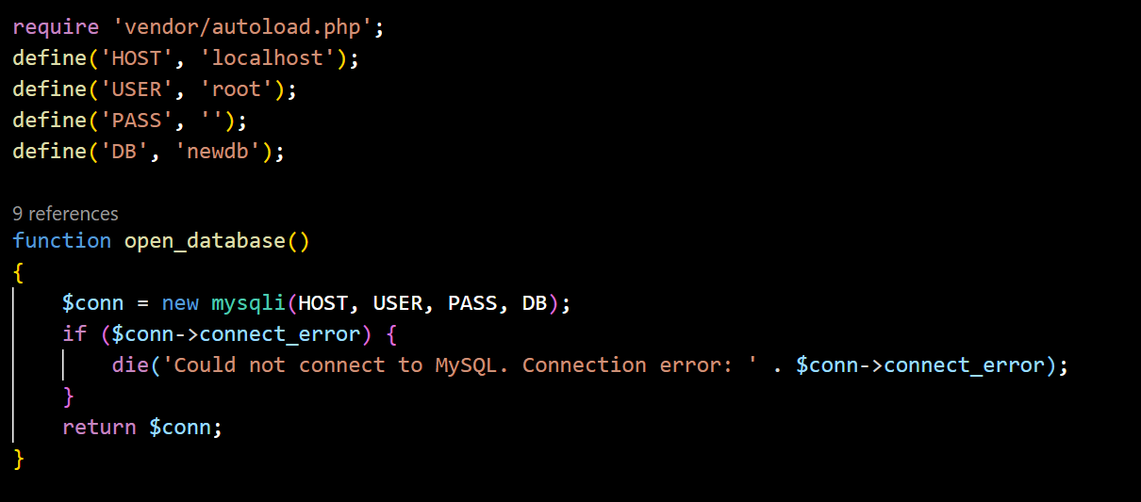

1. Function login(): to check password (match or not) and user validation (if user has account before or not, account is activated or not via email).

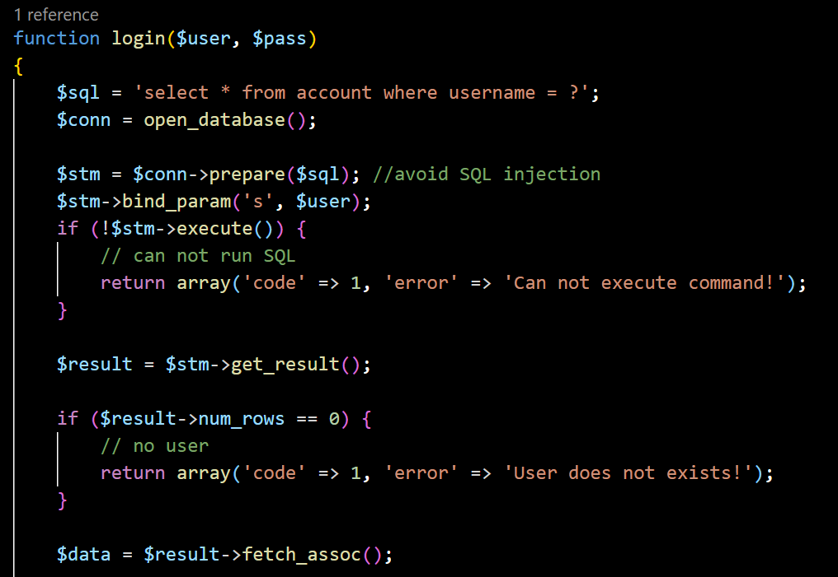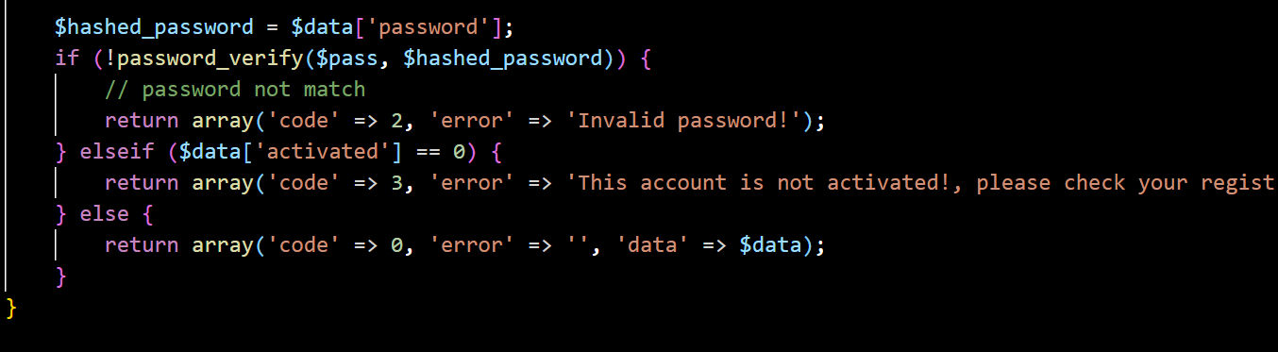

1. Function is_email_exists($email): to check if email is used or not because it is unque

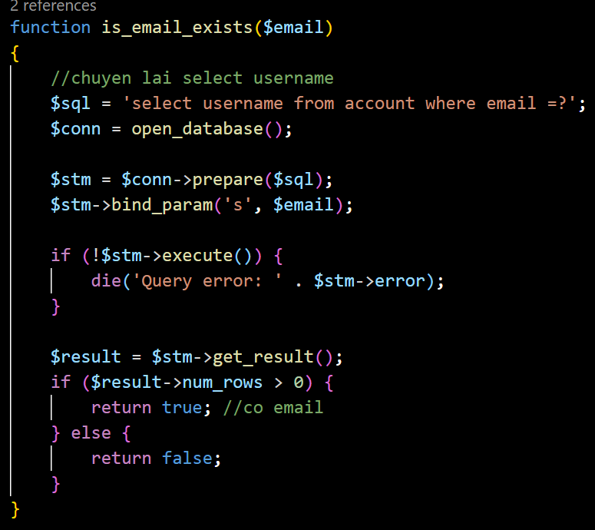

1. Function register(): to register the new account and insert into database.

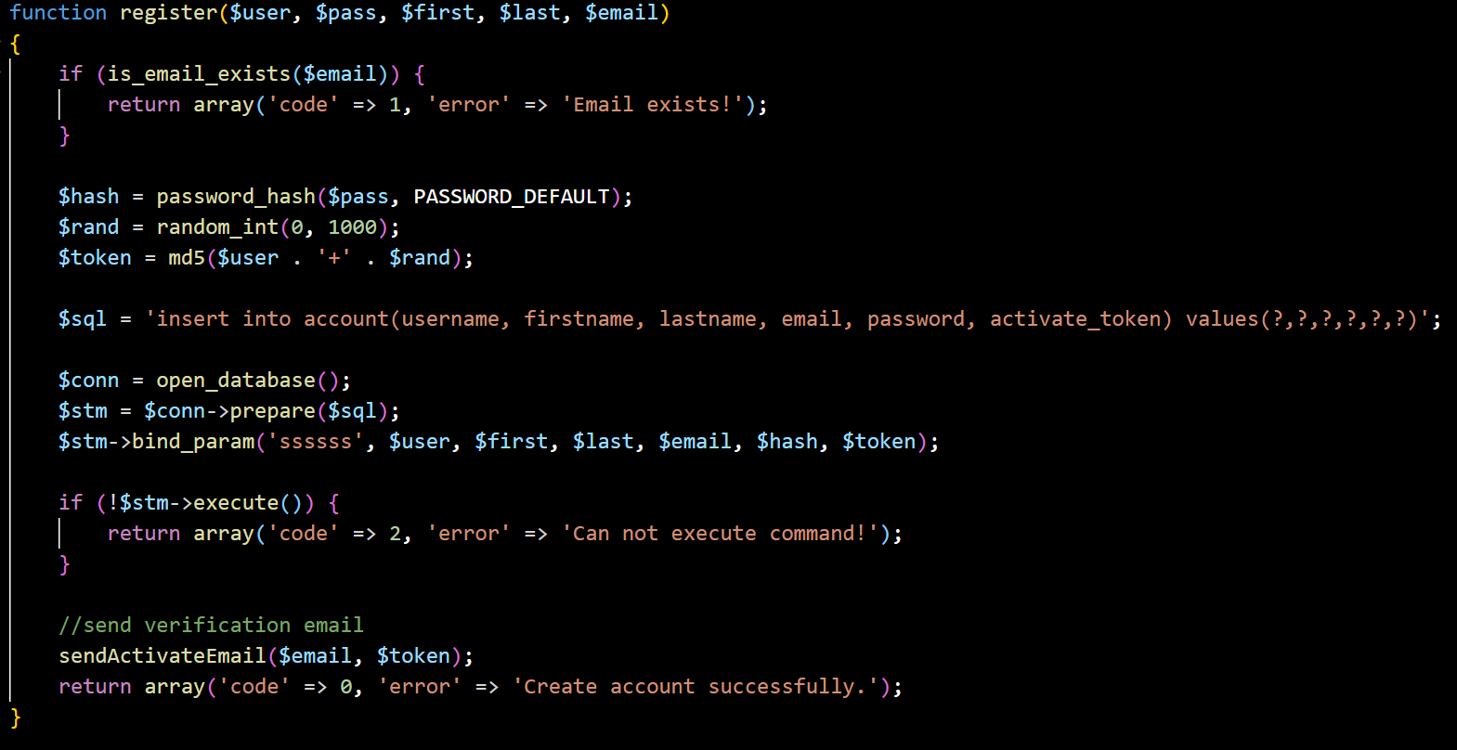

1. Function register_more(): same as function register() but it has more parameters.

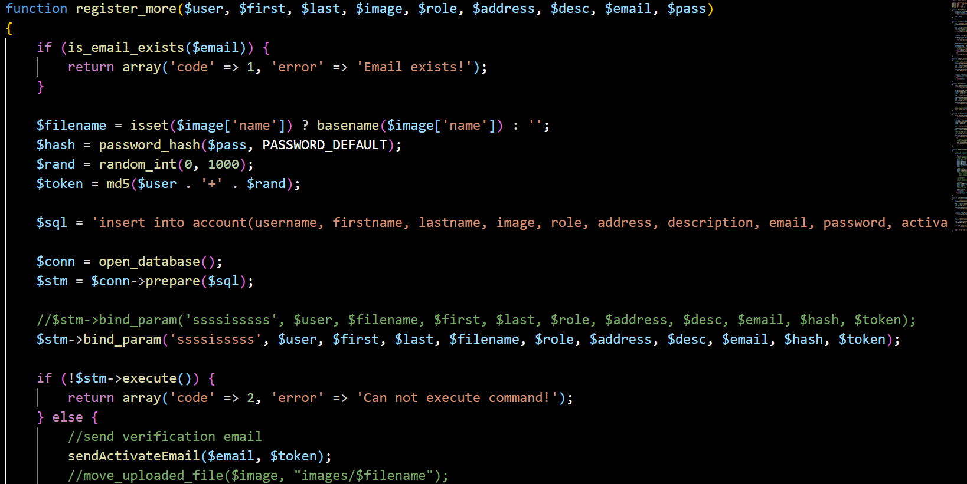

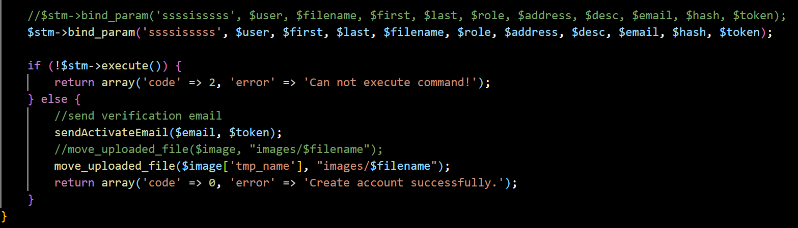

1. Function update_user(): to edit user account (admin/staff) and update it in database.

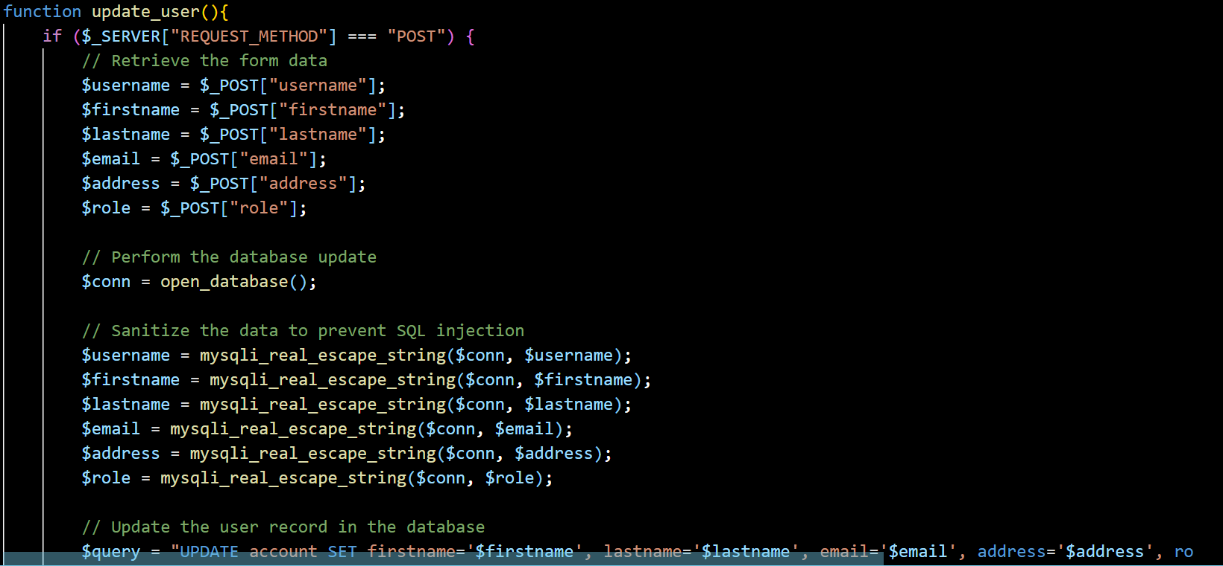

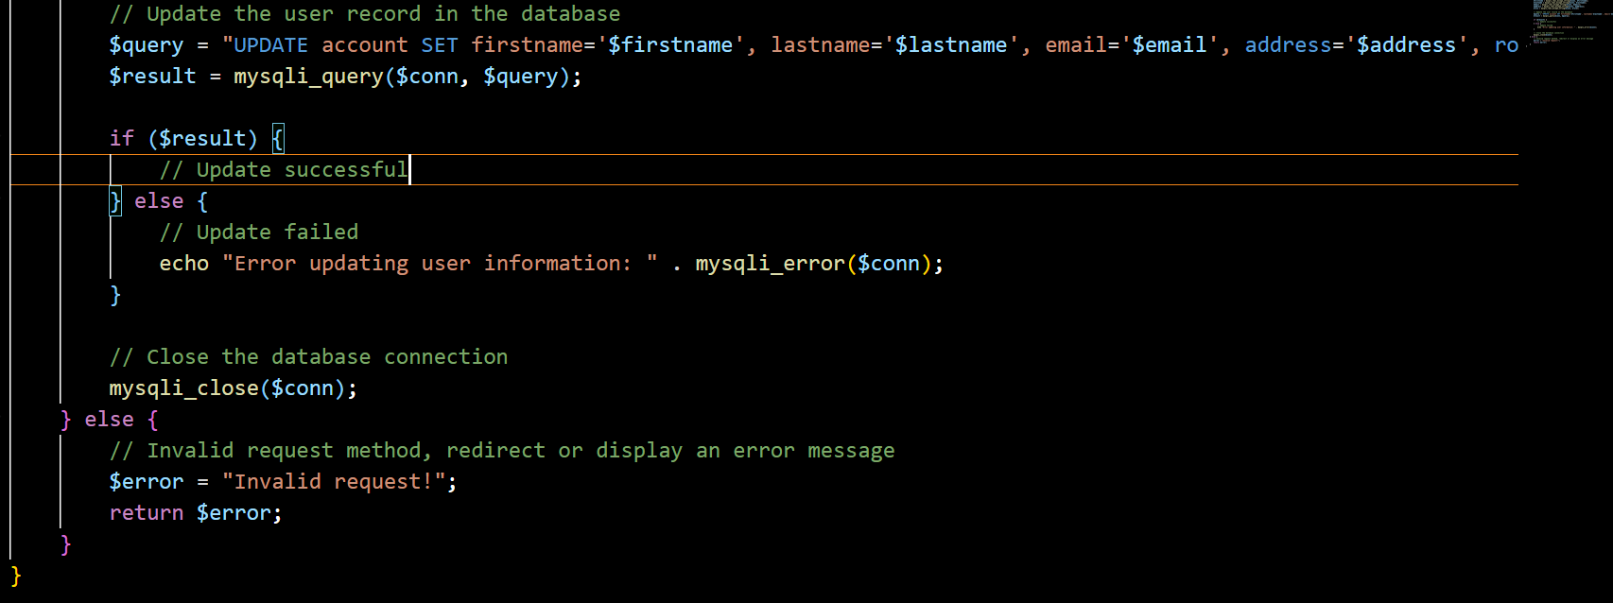

1. Function sendActivateEmail(): is to config the email server to send a validation to register email.

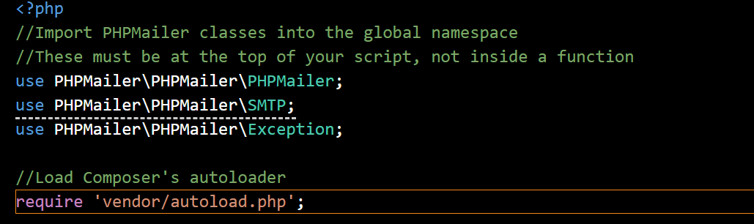

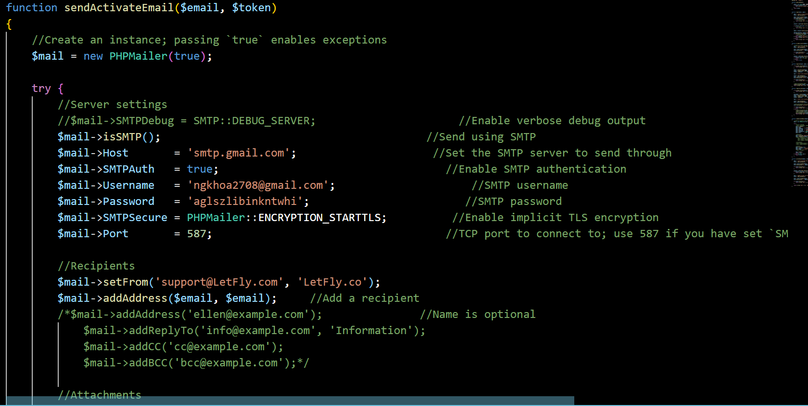

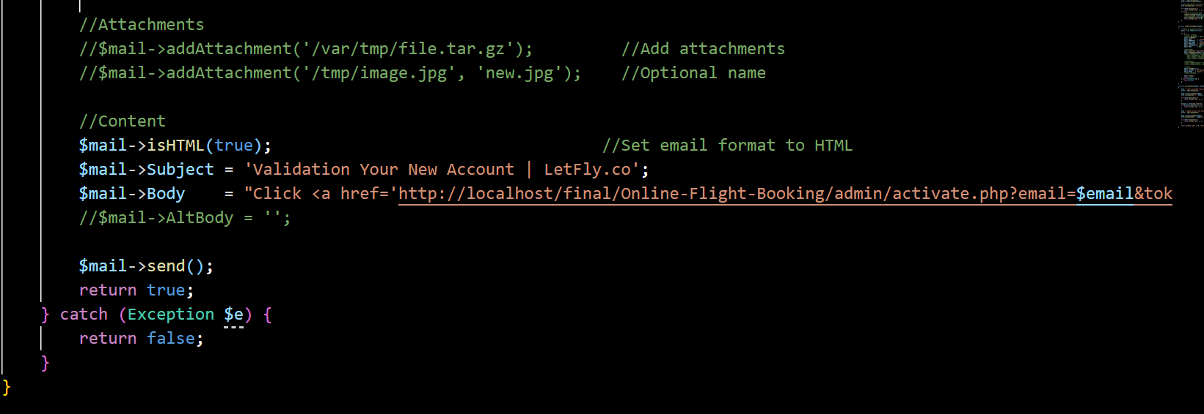

1. Function activeAcount(): is to check if the user has click the validation via register email or not. If it good, user account will be actived.

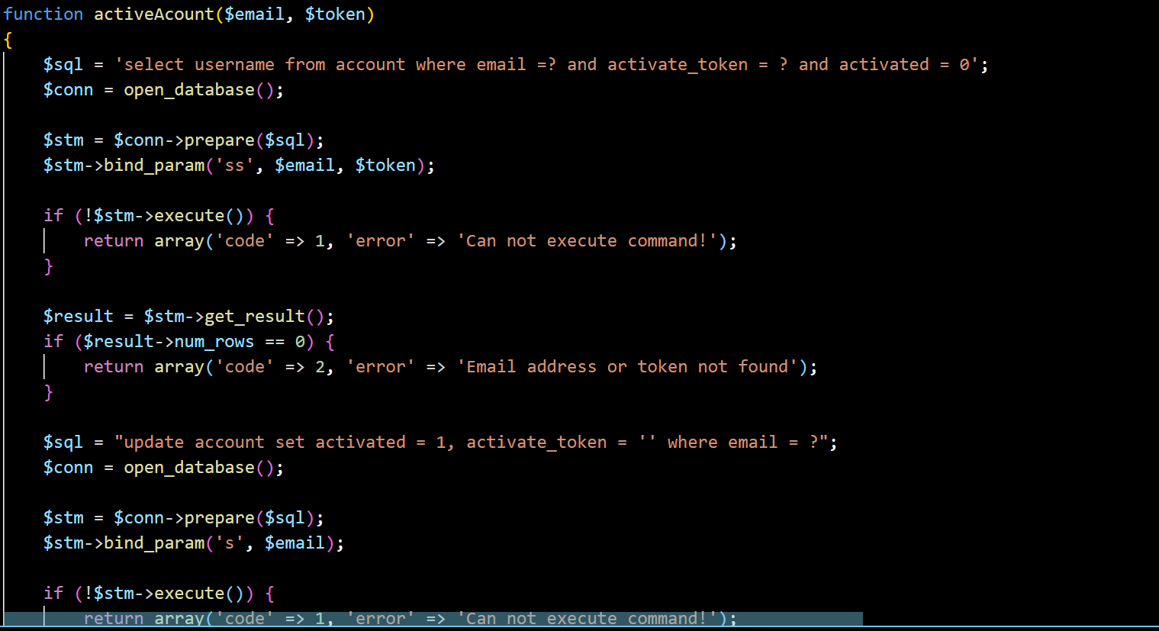

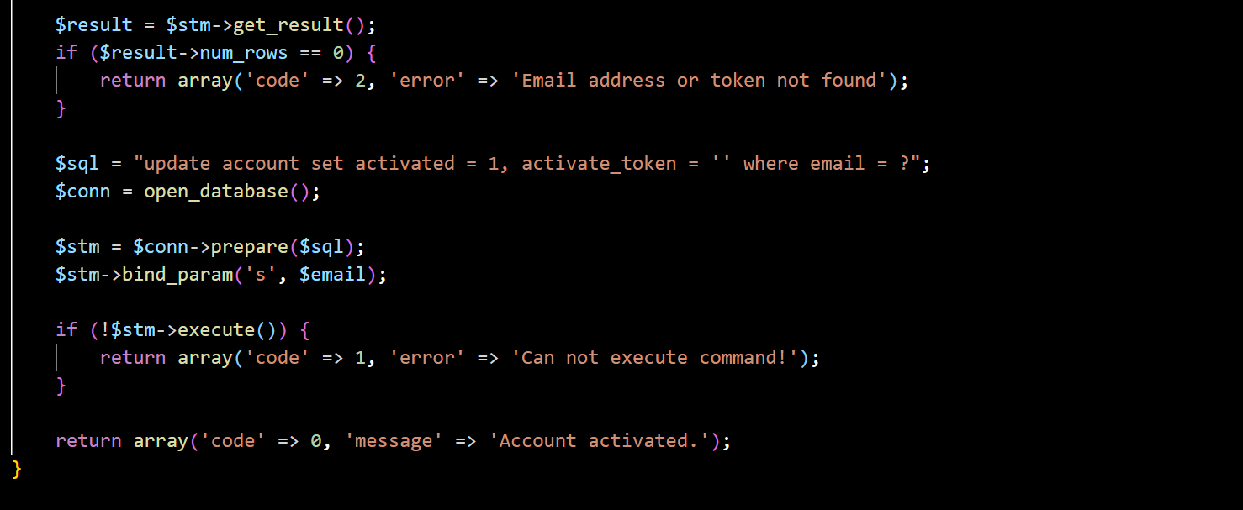

Some event js to make change password show or not.

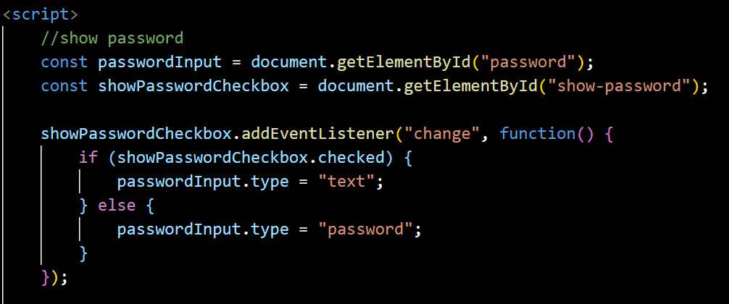

These js function is to display slider in login management.

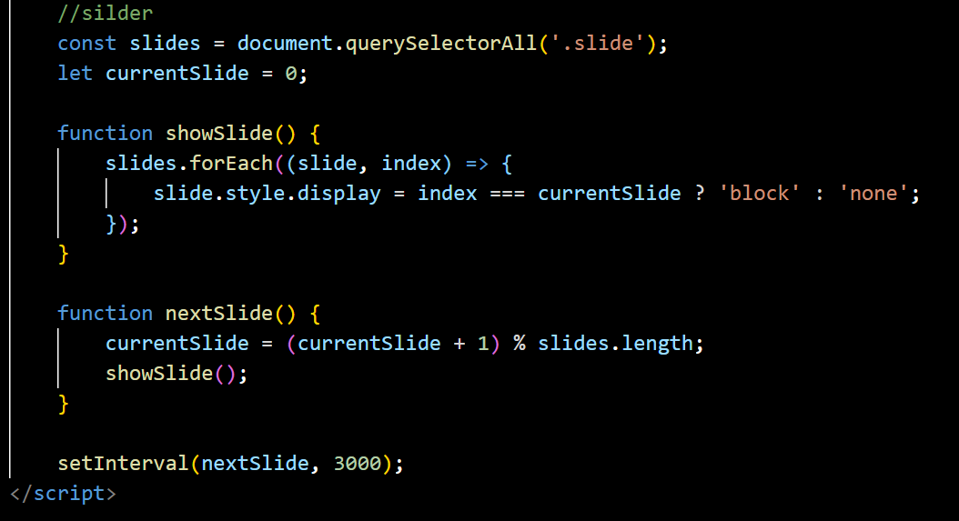

This js is for automatically redirect page from regiser page to login page after 6s.

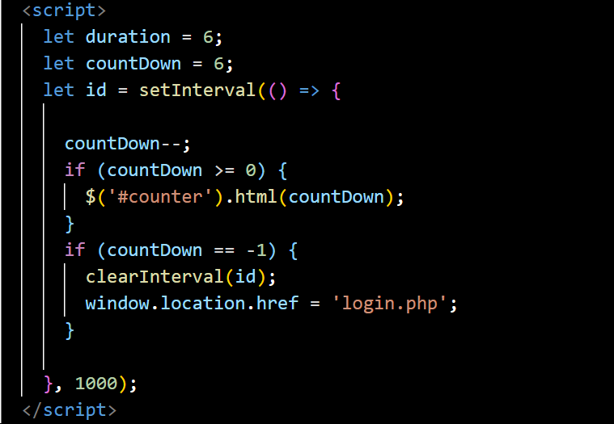

This js function is for display image over the website.

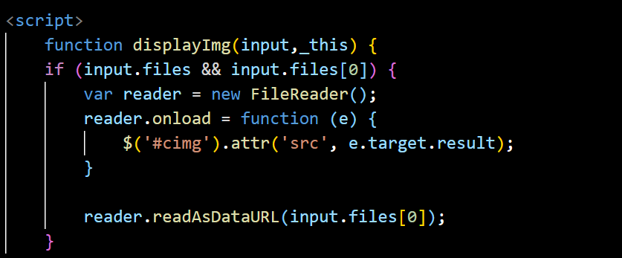

This function is for show confirm delete user form using query to process.

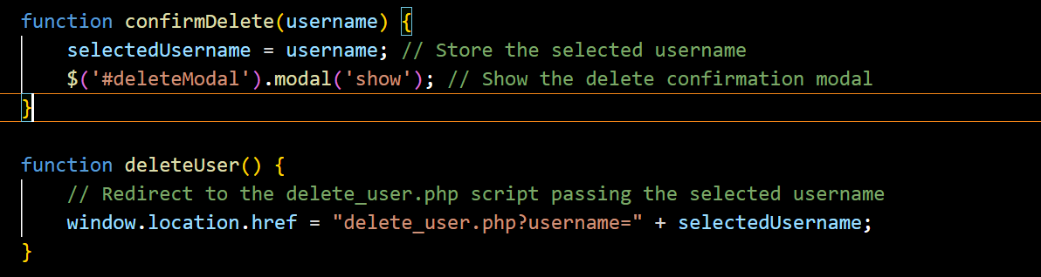

This function is for show confirm edit user form and using query to process.

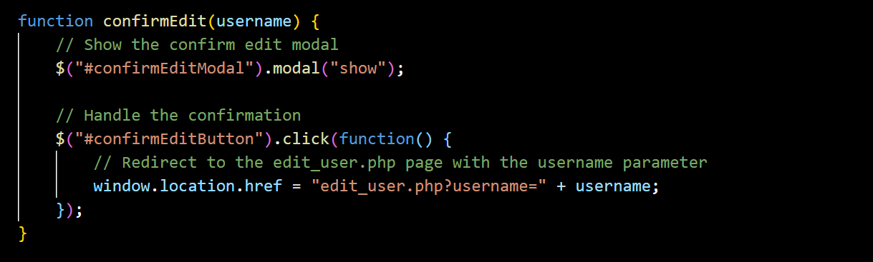

This js function is for delete booking flight on the staff/admin page.

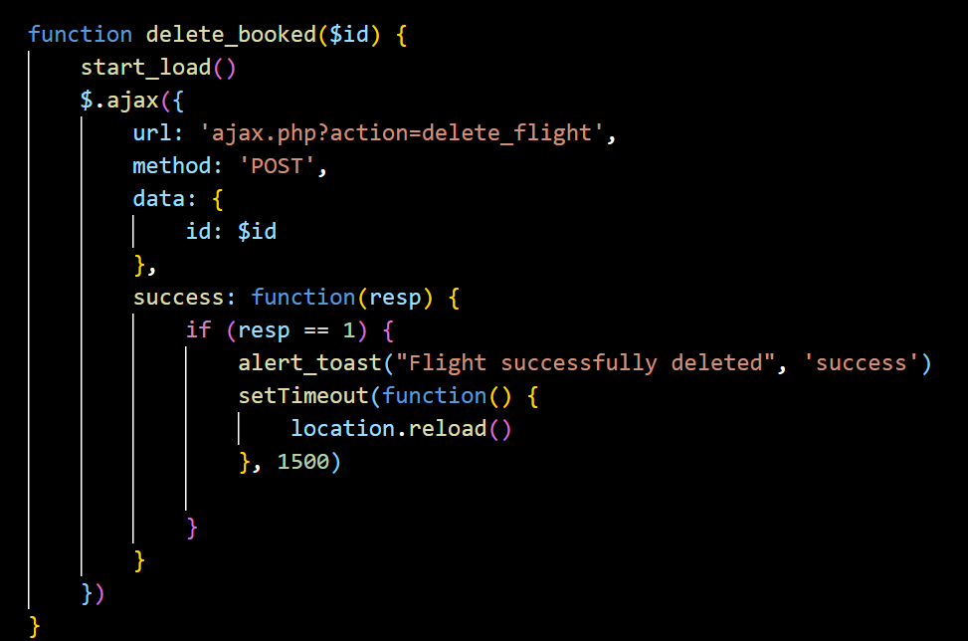

Function delete user in admin/staff account.

